- Open FSD212 spreadsheet to FixedInfo tab (tab at bottom of page).
- Enter your county (EC’s) or district (DEC’s). This entry carries over to data entry page.
- Enter EC and AEC directory information.
- Enter ARPSC nets used information.
- Click over to FSD212Monthly tab (tab at bottom of page).
- Enter data for your operation the month column you are reporting on. For instance, use the January column for January data, and so on.
- Refer to this chart for row by row instructions:

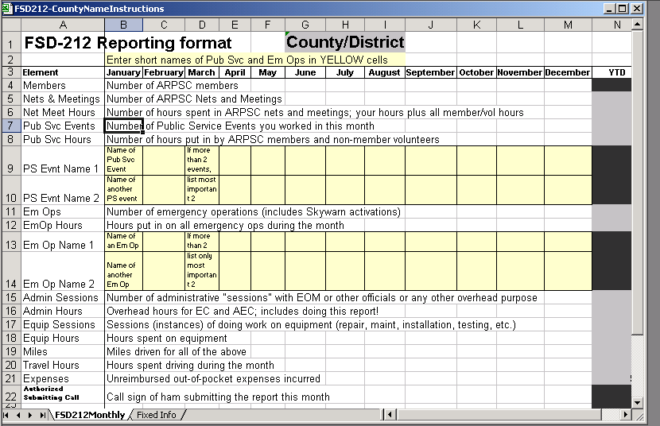

NOTE: THE YELLOW-TINTED ROWS ARE FOR BRIEF TITLES OR IDENTIFERS FOR PUBLIC SERVICE EVENT AND EMERGENCY OPERATIONS. Enter just enough info so you (and your OEM) will recognize the event. If you have more than two events in the month, identify only the two most important. Text will wrap in these cells, but keep your entry as brief as possible.

- Sign the report with the call sign of the submitter in line 22.
- SAVE THE SPREADSHEET AS: FSD212-County/Dist.xls where County/Dist is your county or district name. This makes it easier to find in archives when questions come up.
- Email your report to reports@mi-arpsc.org, your DEC and your OEM. Reports are due the 5th of the month following the month being reported. That is the January report is due February 5th, and so on.

